Program Flow Logic

Christine Hodges

Rasmussen College

Author Note

This paper is being submitted on June 5th, 2018 for Dr. James Groom’s CIS Computer Science Capstone course.

|  |  |  |  |  |  |  |
| --- | --- | --- | --- | --- | --- | --- |
| **Functional Requirement (FR) ID** | | **Task** | **Task Description** | **Estimate Completion Date** | **Actual Completion** | **Does feature function Y/N** |
| **Phase 1: Planning** | | | | |  |  |
| **FR001** | Project Planning | | Create a project plan explaining about the application | 5/13 | 5/11 | Y |
| **FR002** | Determine project Platform | | Determine the coding language and connectivity | 5/13 | 5/11 | Y |
| **Phase 2: Developing and Testing** | | | | |  |  |
| **FR003** | Create Home Screen | | Code main screen | 5/20 | 5/15 | Y |
| **FR004** | Create Login screen | | Code main screen with login functions. The login screen shall allow a new user to register and the login screen shall allow all registered users to login. | 5/20 | 5/15 | Y |
| **FR005** | Create Database functions | | The database shall store usernames and passwords. The database shall allow a new user to register and store their login credentials. | 5/20 | 5/15 | Y |
| **FR006** | Test Code and database function | | Ensure new users can register and stored users can login | 5/20 | 5/15 | Y |
| **FR007** | Create code for screen 1 | | Provide code and display for screen 1 | 5/27 | 5/25 | Y |
| **FR008** | Create Code for screen 2 | | Provide code and display for screen 2 | 5/27 | 5/25 | Y |
| **FR009** | Code for Screen 3 | | Provide code and display for screen 3 | 6/3 | 5/29 | Y |
| FR010 | Create Log-out on Home screen | | The home screen shall have a log-out feature. | 6/3 | 5/15 | Y |
| FR011 | Create Log-out on Screen 1 | | Screen 1 shall have a lout-out feature. | 6/3 | 5/25 | Y |
| FR012 | Create Log-out on Screen 2 | | Screen 2 shall have a lout-out feature. | 6/3 | 5/25 | Y |
| FR013 | Create log-out on screen 3 | | Screen 3 shall have a lout-out feature. | 6/3 | 5/25 | Y |
| **Phase 3: Application Testing** | | | | |  |  |
| FR014 | Test Log-out on all screens Home, Screen 1, 2, & 3 | | The log-out feature shall work on each screen. | 6/3 | 5/25 | Y |
| FR015 | Test code and screen functionality | | Test and produce screen shots of successful functionality | 6/3 | 5/29 | Y |
| FR016 | Create program flowchart | | Create a logical flowchart | 6/10 | 6/5 | Y |
| FR017 | Provide proof of testing procedures | | Produce proof of testing all screens and procedures | 6/10 | 6/5 | Y |
| FR018 | Produce screen shots of screen function | | Provide screen shots of the successful screen functions | 6/10 | 6/5 | Y |
| FR019 | Provide final flowchart | | Create a final flowchart of application architecture | 6/15 | 6/5 | Y |
| FR020 | Submit project for review with project free of errors and screens shots showing professional flow from one section to another | | Provide all code for program, screen shots, and logic | 6/15 | 6/5 | Y |

**\**

**roject Outline with Functional Requirements**

The Project Plan will be divided into three phases, planning, developing, and testing. The area highlighted in yellow includes what is shown in screenshots below. All code can be reviewed at my GitHub repository: <https://github.com/fitactivemomgineer/CompSciCapstone>

View Front-End for Screen 1:

<http://chodgescapstone.centralus.cloudapp.azure.com/welcome.php>

View Front-end for Screen 2:

<http://chodgescapstone.centralus.cloudapp.azure.com/runners.html>

View Front-end for Screen 3:

<http://chodgescapstone.centralus.cloudapp.azure.com/bikers.html>

View Register New User Screen:

<http://chodgescapstone.centralus.cloudapp.azure.com/register.php>

View Login with Stored User:

<http://chodgescapstone.centralus.cloudapp.azure.com/login.php>

View Back-End Code for Screen 1:

<https://github.com/fitactivemomgineer/CompSciCapstone/blob/master/welcome.php>

View Back-End Code for Screen 2 <https://github.com/fitactivemomgineer/CompSciCapstone/blob/master/runners.html>

View Front-end for Screen 3:

<https://github.com/fitactivemomgineer/CompSciCapstone/blob/master/bikers.html>

View Register New User Screen:

<https://github.com/fitactivemomgineer/CompSciCapstone/blob/35a383d5c85b2f7180fe19e03a0f27e15469017b/register.php>

View Login with Stored User:

<https://github.com/fitactivemomgineer/CompSciCapstone/blob/35a383d5c85b2f7180fe19e03a0f27e15469017b/login.php>

**New User Login Screen Functions- URL** <http://chodgescapstone.centralus.cloudapp.azure.com/login.php>

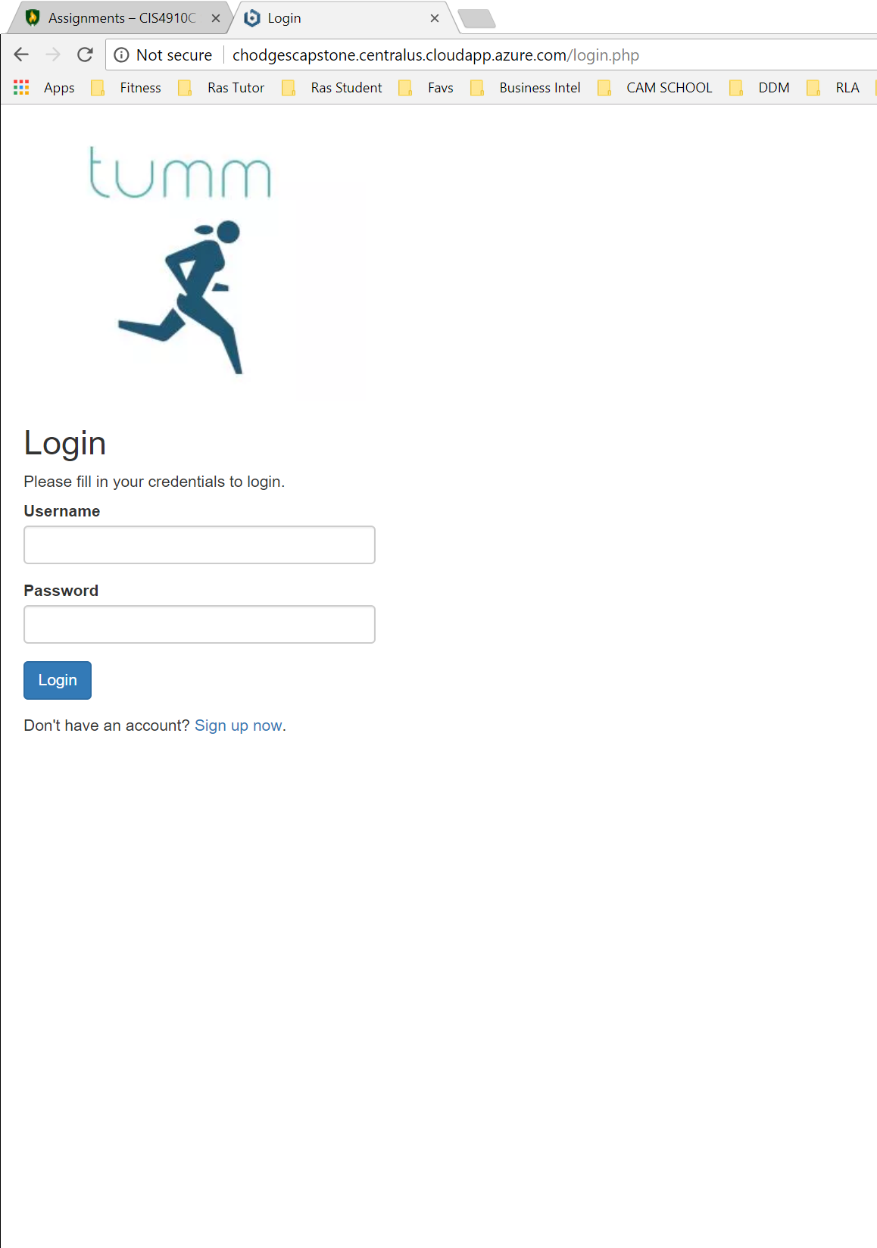

**Stored User Register Screen Functions- URL -** <http://chodgescapstone.centralus.cloudapp.azure.com/login.php>

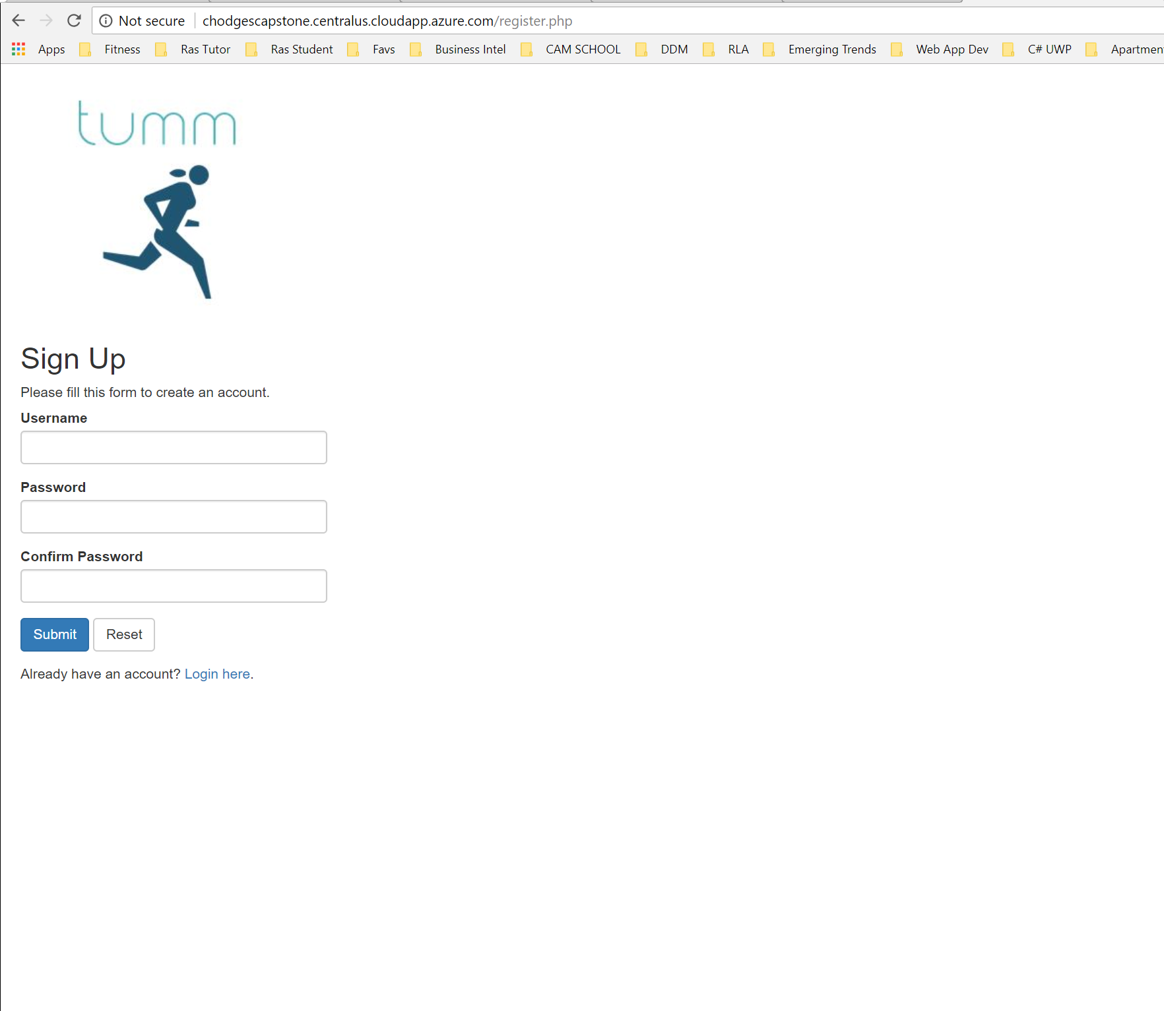

**Screen 1 functions properly – URL:** <http://chodgescapstone.centralus.cloudapp.azure.com/welcome.php>

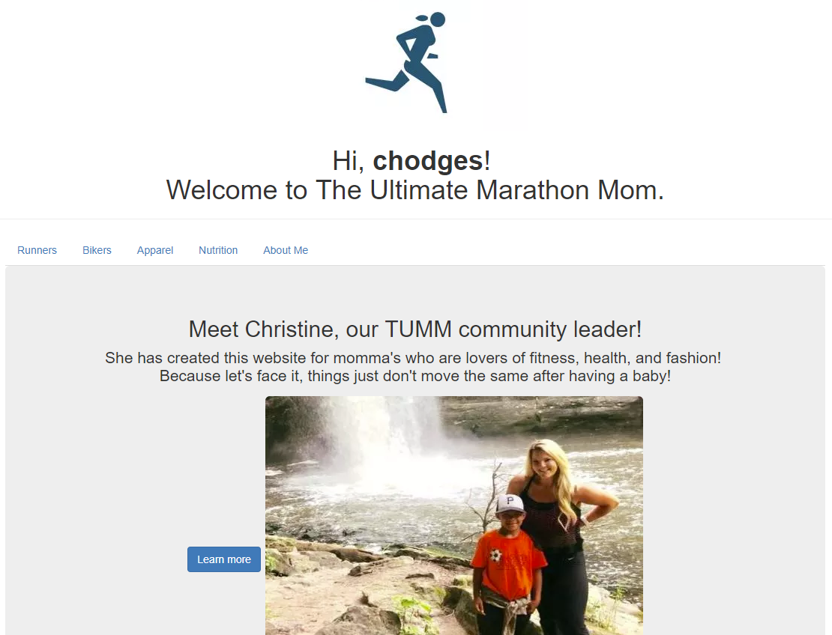

Screen 2 functions properly – URL - <http://chodgescapstone.centralus.cloudapp.azure.com/runners.html>

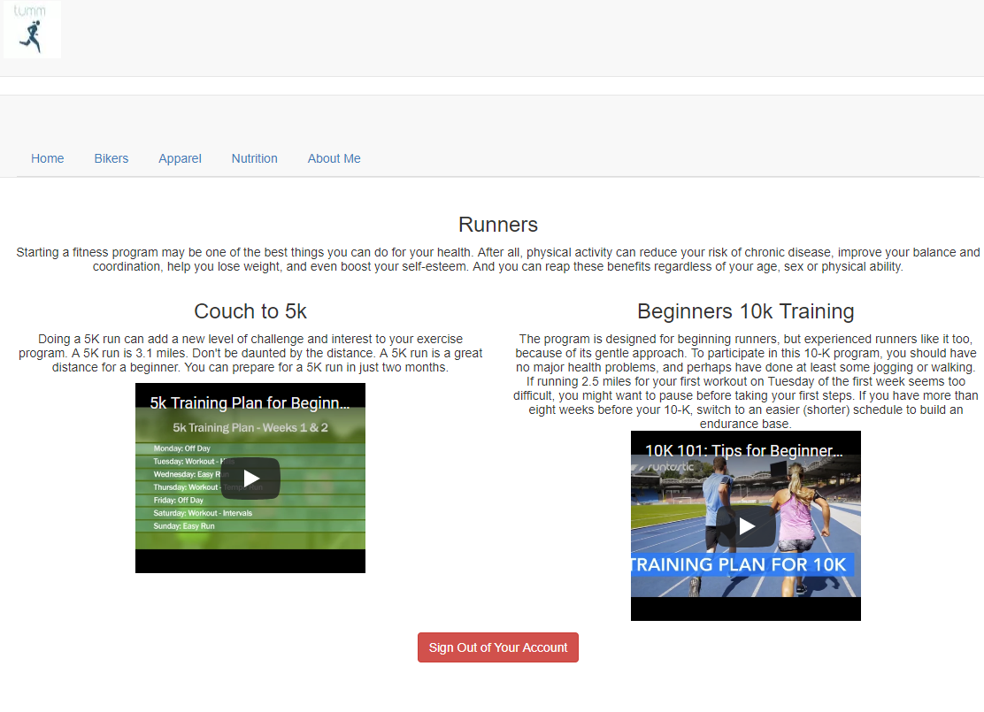

**Screen 3 functions properly – URL:** <http://chodgescapstone.centralus.cloudapp.azure.com/bikers.html>

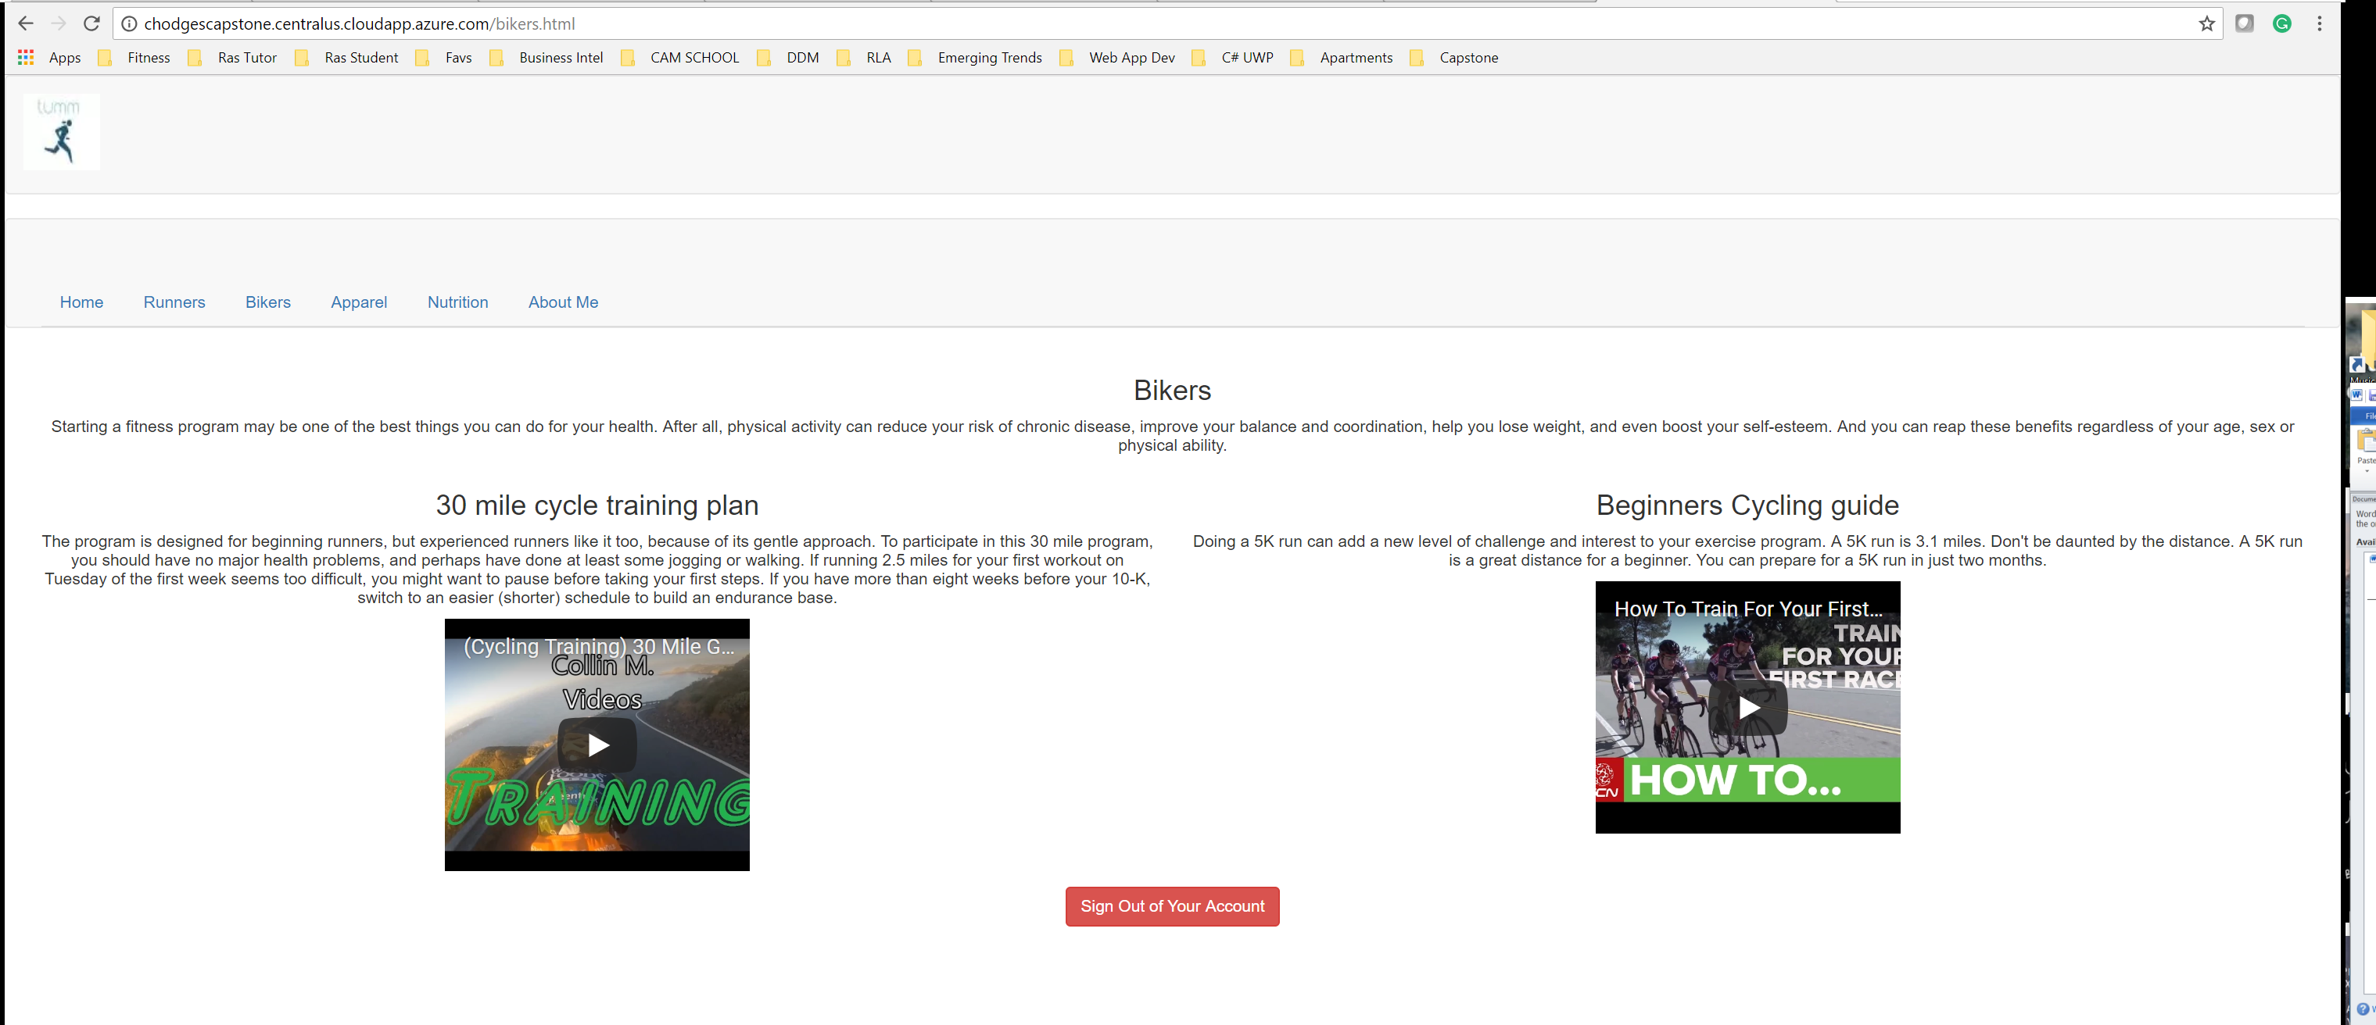

Log-out functions on all screens: The log-out feature is in a red button at the bottom

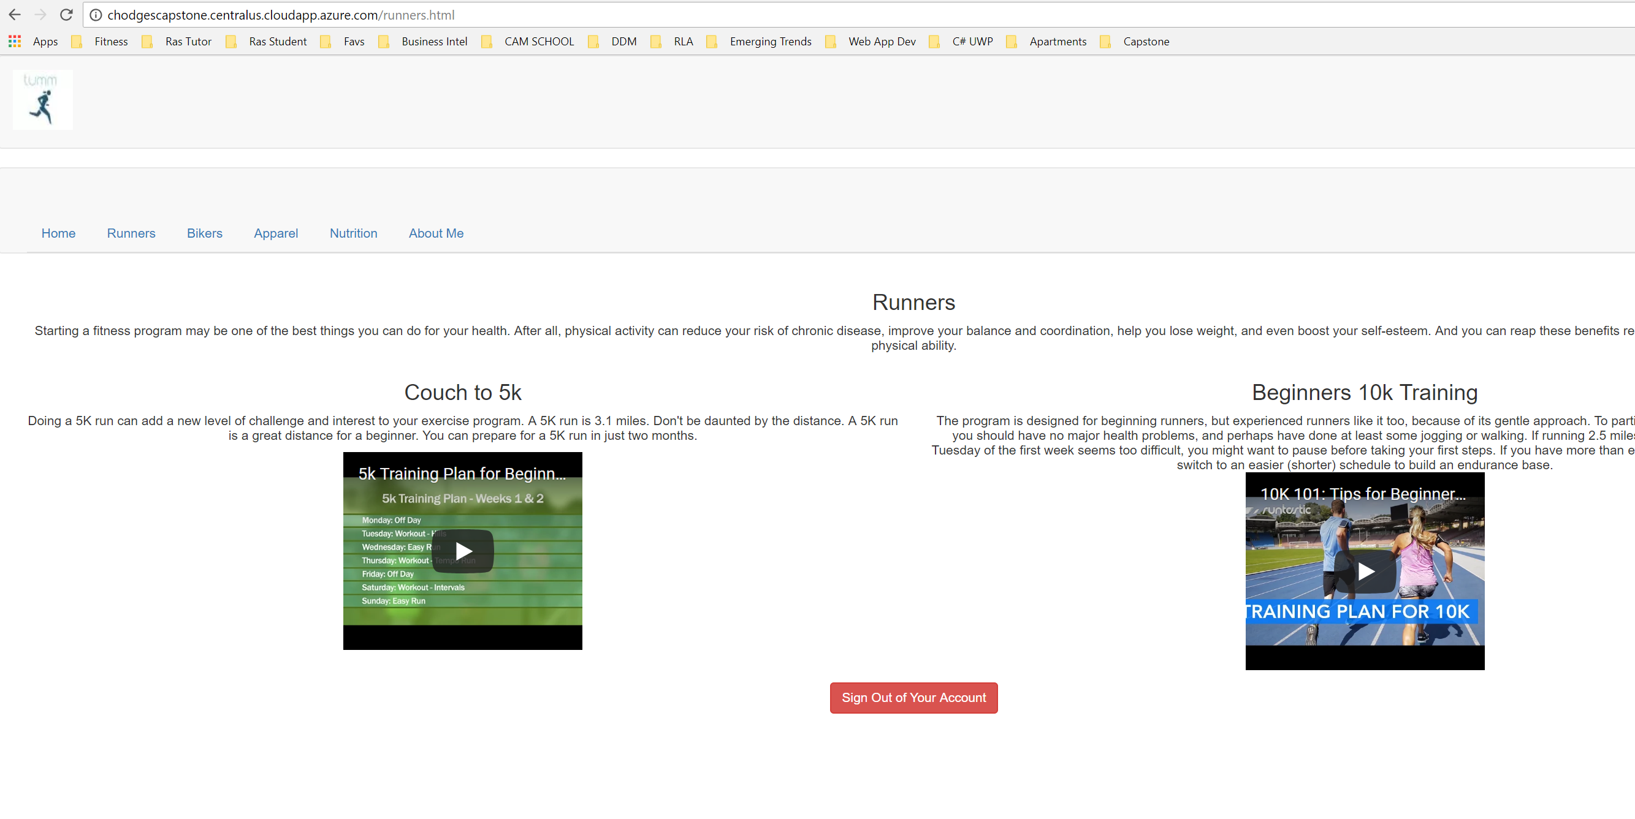

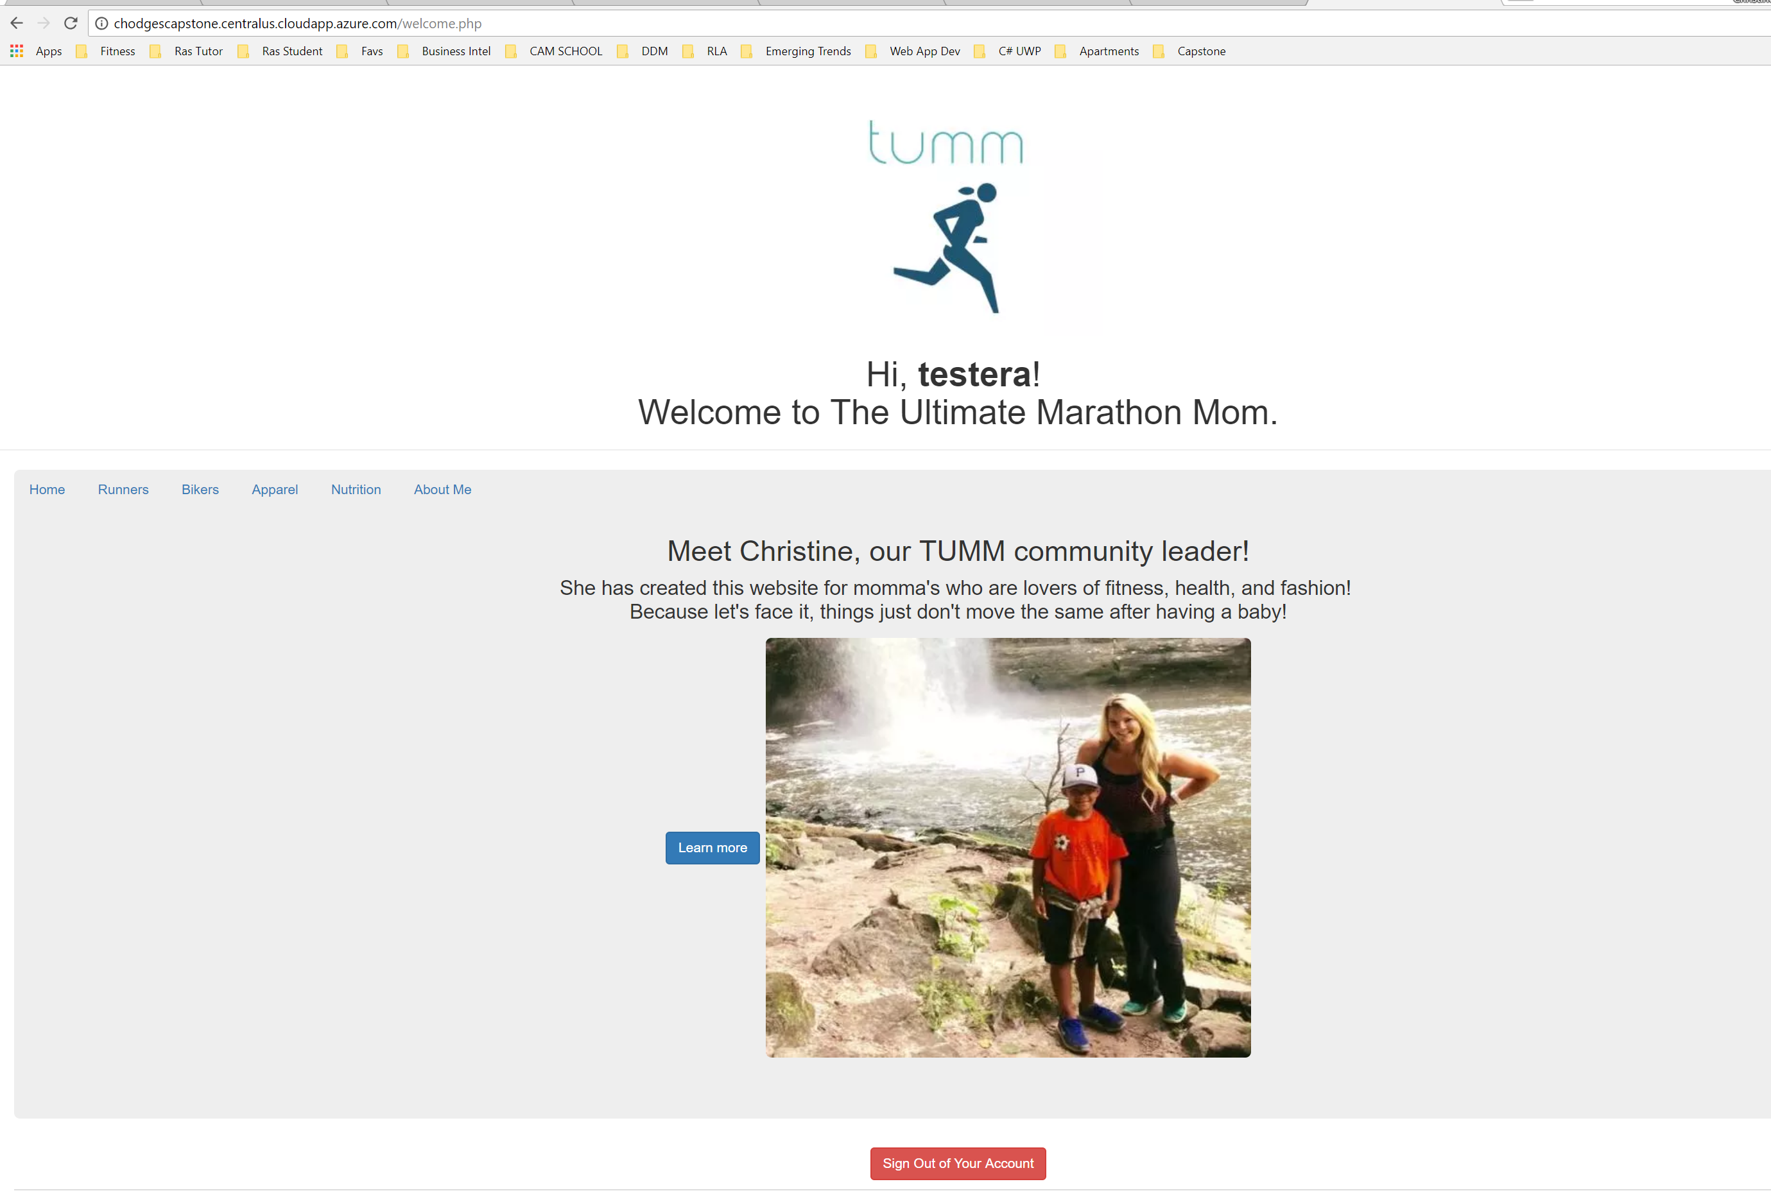

Create Flowchart : To view a larger version URL - <https://drive.google.com/file/d/18ZXUxPoAMO2vIgVLVNQdisxuJoCGjd9N/view?usp=sharing>

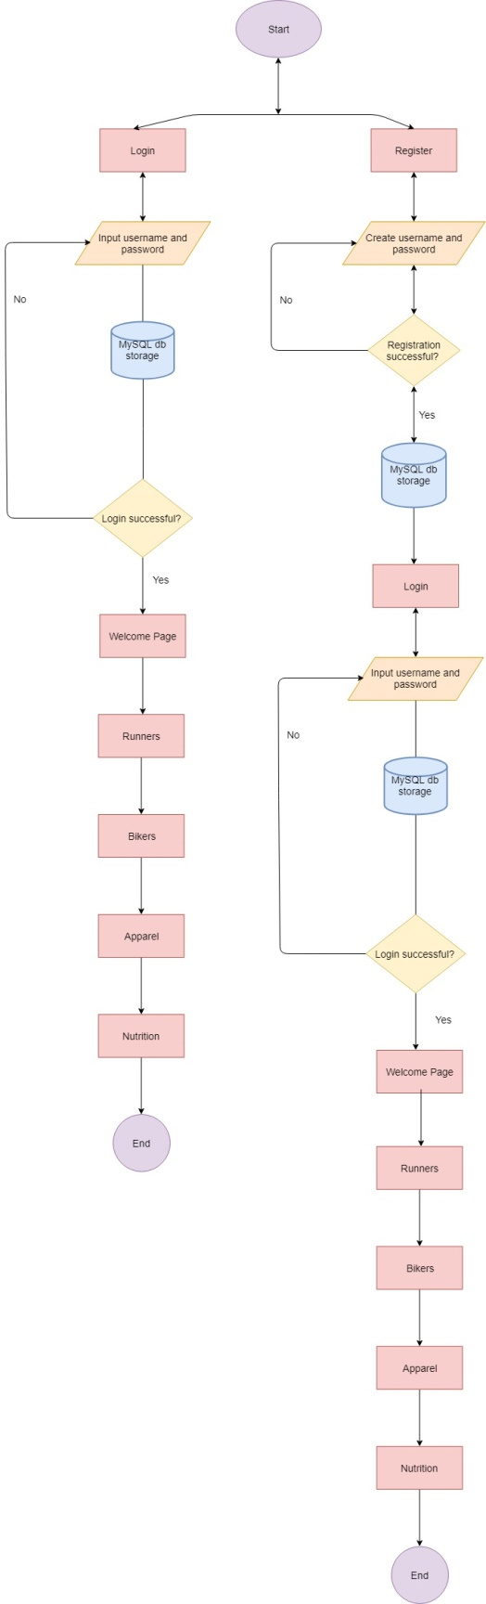

**Logout function** – When the user selects logout from any URL it redirects them to the login page

If a user enters an incorrect password or is not registered the end-user is notified:

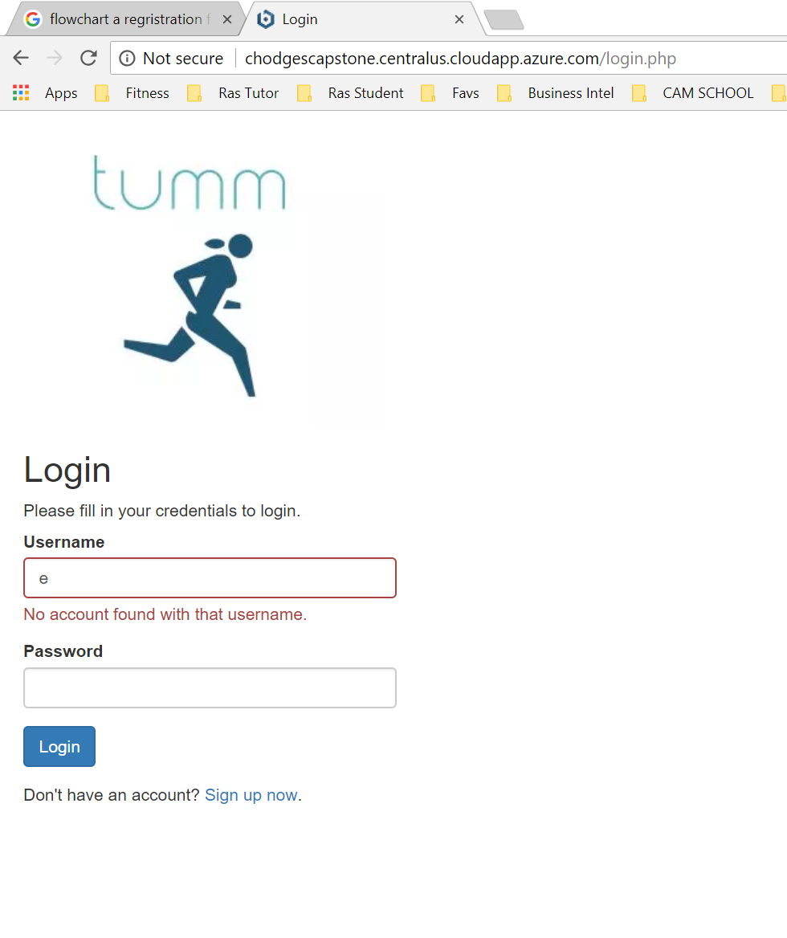

**Important Backend details:**

**Storage Account**

Chodgescapstonesa.core.windows.net

**Resource group**

Chodgescapstonerg

**VM/LAMP**

Chodgescapstonevm

Username: chodges

Password: ---------------

**DNS / FQDN**

Chodgescapstone.centralus.cloudapp.azure.com

**Bitnami password:**

Ce4qd4HBJZG5

**MySQL Database name**

Tummdb

**Filezilla site path:** /opt/bitnami/apache2/htdocs

**Atom to Git for Capstone:** C:\Users\ChristineHodges\Desktop\Desktop\Capstone\TUMM\CompSciCapstone

